**Student Worksheet: The race to net zero**

**Directions**: Drastic cuts to greenhouse emissions are needed to prevent even more catastrophic consequences than the rising sea levels, extreme weather and other impacts our warming world has already faced. Scientists have mapped out potential paths to net-zero, when greenhouse gases emitted are balanced by those removed. This includes decreases in emissions from transportation, industry and other sectors.

Read the short summary, graph title and caption before completing the questions below. Your teacher may have you use Padlet, Kahoot, or Mentimeter to provide responses.

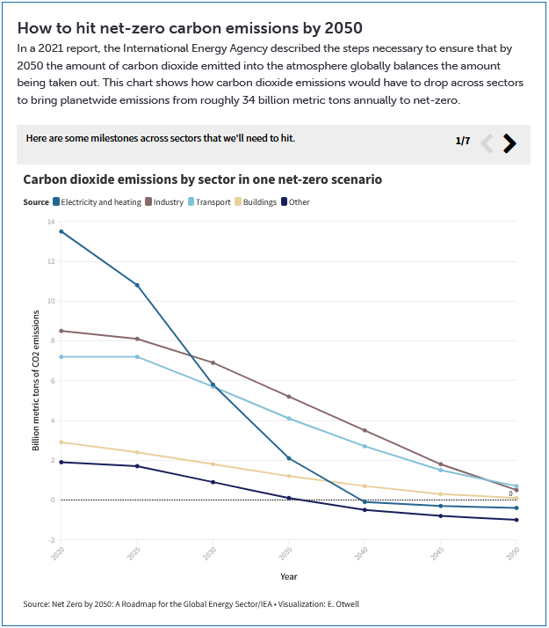

**Graph Questions**1. According to the graph, what source produced the most CO2 emissions in 2020?

2. Name two types of transportation that produce CO2 emissions directly and one type that would not produce CO2 emissions.

3. In what year are the emissions from electricity and heating projected to be very similar to the emissions from transport?

4. In your opinion, which type of fuel use should be used in the next generation of cars? Justify your opinion by stating two benefits of this type of fuel. Suggest a negative effect of using this fuel.