Student Worksheet: Earth’s impact craters
Directions: Space rocks that have smashed into our planet have left impact craters. Many of the craters have been wiped away by erosion, but scientists have cataloged the survivors, including some that are over one billion years old.
Read the short summary, graph title and caption before completing the questions below. Your teacher may have you use Padlet, Kahoot, or Mentimeter to respond.
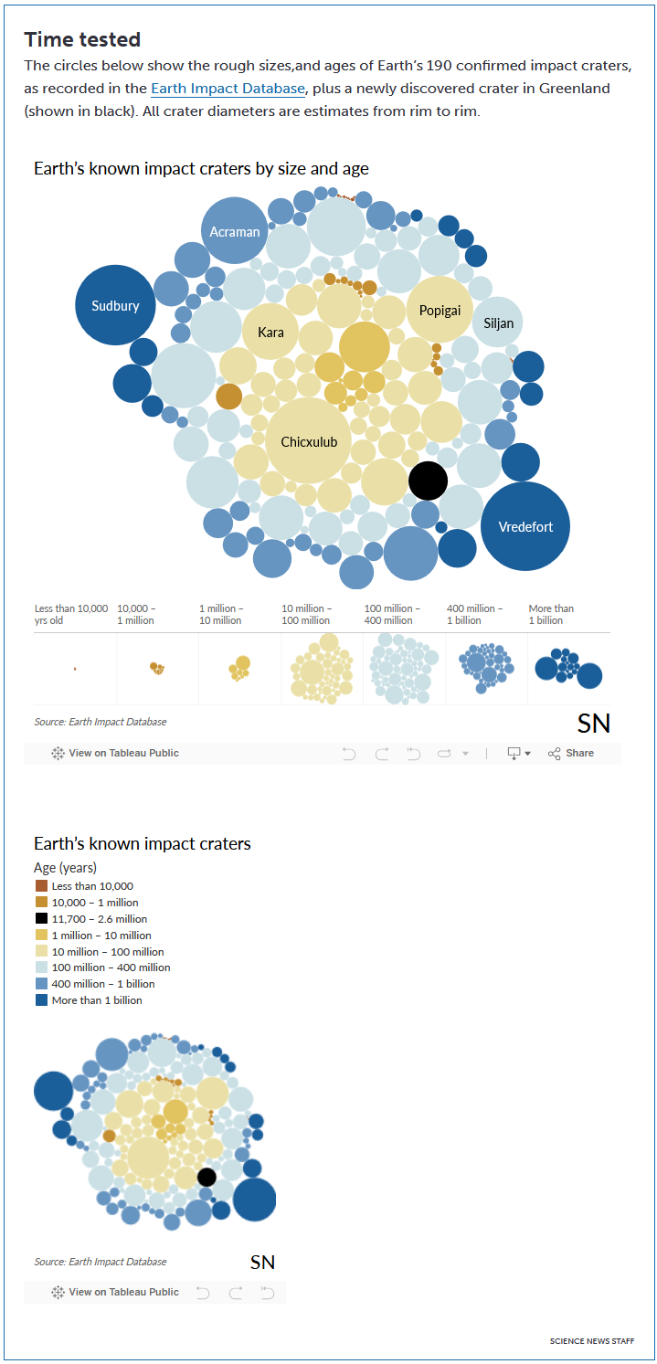

Graph Questions
1. Rank the following impact craters in order from smallest to largest: Sudbury, Popigai, Siljan

2. Which of the impact craters listed below are over one billion years old? Choose all that apply.
- Sudbury
- Popigai
- Siljan
- Kara
- Chicxulub
- Vredefort

3. How do you think a large impact from a space rock could damage an ecosystem? Please include at least three effects of a large impact.

