Student Worksheet: Trends in alcohol-induced death rates
Directions: Alcohol-related deaths have increased yearly over the last 20 years. From 2019 to 2020, in the first year of the COVID-19 pandemic, the death rate from alcohol use rose sharply — at a much greater rate than in recent years.
Read the short summary, graph title and caption before completing the questions below. Your teacher may have you use Padlet, Kahoot, or Mentimeter to provide responses.
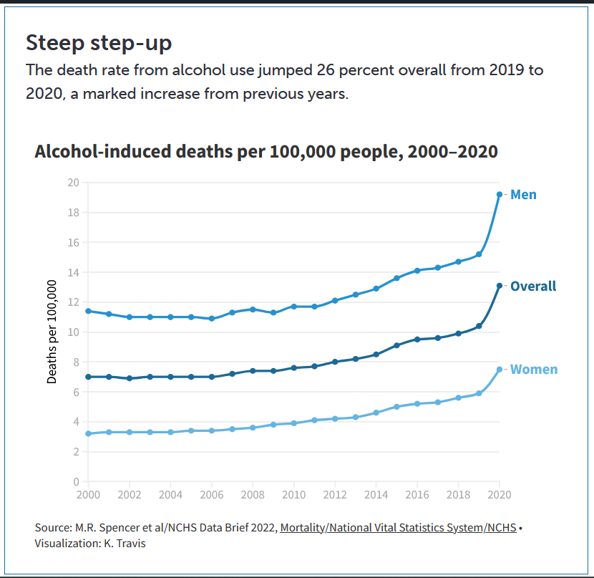

Graph Questions
1. When was the lowest rate of alcohol-induced deaths per 100,000 men? What was the number of deaths per 100,000?

2. In what year did the number of deaths in women climb above 4 deaths per 100,000 deaths?

3. Looking at the overall data, what is the general trend of the rate of alcohol-induced deaths from 2000 to 2020? Explain. What factors may have contributed to that trend?

