Student Worksheet: Genetic genome gaps cause blind spots
Directions: Scientists have had a rough draft of the human genome for some 20 years. They hoped to use it for precision medicine, treatments based on an individual’s DNA. But an understanding of the differences between different people’s DNA has been hampered by a lack of diversity in genetic studies known as genome-wide association studies.

Read the short summary, graph title and caption before completing the questions below. Your teacher may have you use Padlet, Kahoot, or Mentimeter to provide responses.

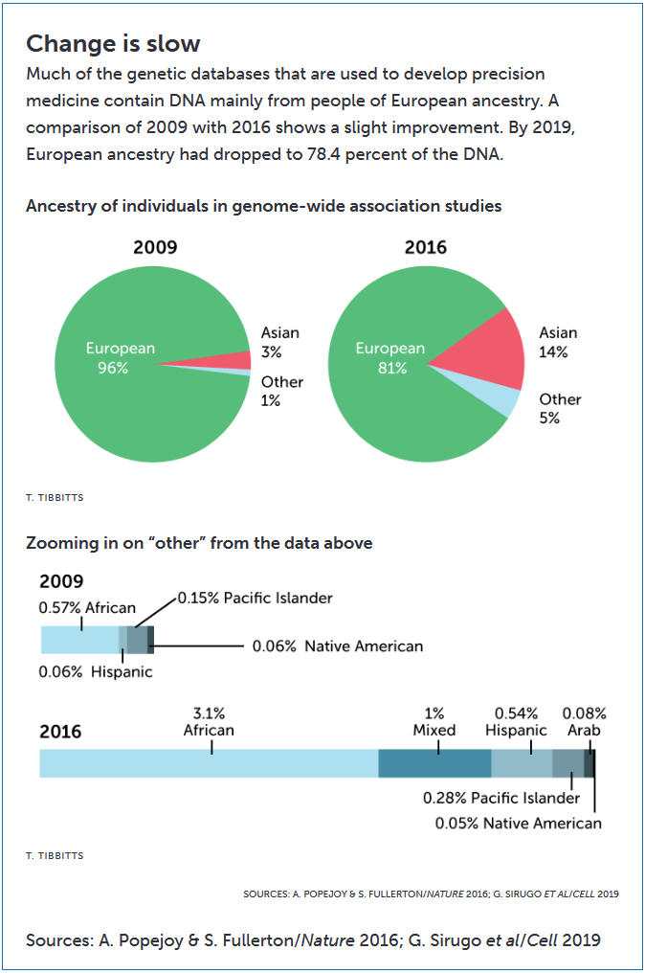
Graph Questions
1. Compare the makeup of individuals in the genome-wide association studies in 2009 to the makeup in 2016.

2. What ancestries are included in the “other” data in 2016 that were not included in the “other” data in 2009? Select all that apply.

3. Explain why the 2009 bar that is zooming in on “other” is shorter than in the 2016 bar.

4. Optional Extension: In science, claims are typically supported with data to provide evidence and reasoning. Read the following claim: Getting people from all over the world to take part in genetic research might seem like the way to boost diversity. Please justify why Constance Hilliard, an evolutionary historian, disagrees with this statement using evidence from the article.

