Student Worksheet: Analysis of marine heat waves
Directions: Global temperatures are at an all-time high due to the compounded effects of climate change and El Nino. Oceans around the world are warming at an alarming rate. In summer 2023, some 40 percent of the world’s oceans were affected by heat waves.
Read the short summary, graph title and caption before completing the questions below. Your teacher may have you use Padlet, Kahoot or Mentimeter to provide responses.

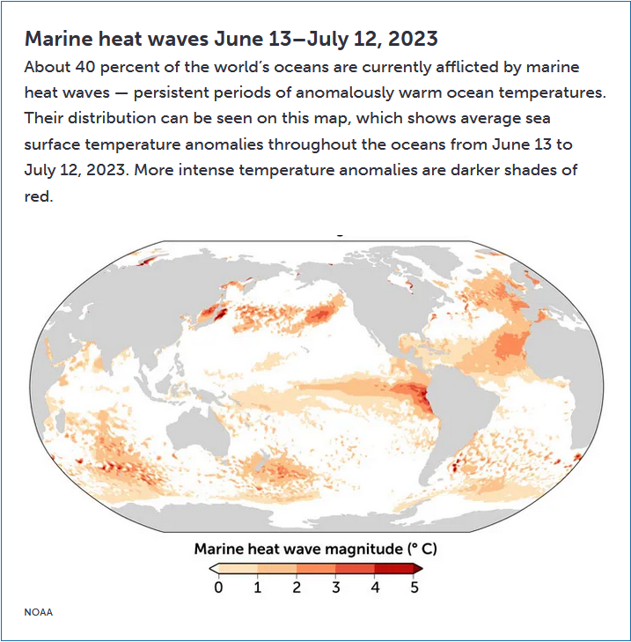

Graph Questions
1. Off the western coast of South America, what is the highest marine heat wave magnitude temperature? (Hint: the continents are shaded in gray above.)

2. What is the range of marine heat wave magnitude in the Pacific Ocean between Asia and North America?

3. What do you think these heat waves are doing to the biodiversity of the ocean life in these hottest zones?

4. Changing ocean temperatures impact both terrestrial and aquatic animals. Give a specific example of a terrestrial organism that will be negatively impacted by ocean temperatures increasing. In addition, identify a specific example of an organism that may be positively affected. Be sure to justify why you picked these organisms.

