Student Worksheet: How do we remember events in history?
Directions: According to a 2022 study, people in the United States often included Thanksgiving as an event important to the country’s foundation along with the Revolutionary War, the Declaration of Independence, Christopher Columbus’s “discovery” of the Americas, the Civil War and British colonization. But the events in most people’s narrative of the first Thanksgiving runs contrary to history. Thanksgiving myths abound because their memory is rooted in story. While such origin stories tend to unify people, they sometimes misrepresent the truth. Tidy tales of history sometimes appear in books and museum exhibits, preserving the group narrative and identity.
Read the short summary, graph title and caption before completing the questions below. Your teacher may have you use Padlet, Kahoot or Mentimeter to provide responses.
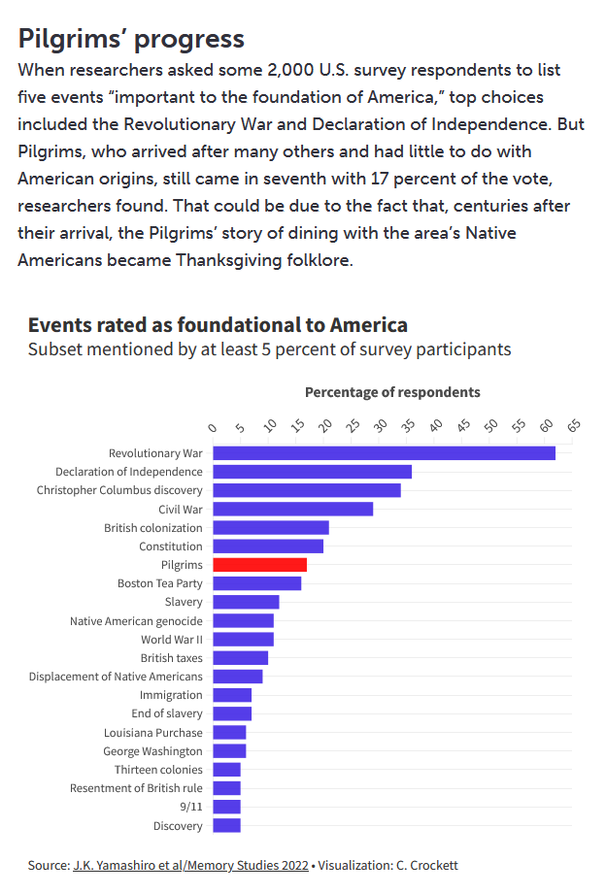
Source: J.K. Yamashiro et al/Memory Studies 2022
Visualization: C. Crockett
Graph Questions
1. What percentage of respondents listed the Thirteen Colonies as a foundational event in American history?
A. 5%
B. 10%
C. 15%
D. 20%

2. Which event was mentioned the most frequently by the participants in the study?

3. Rank the three different wars included in the survey in order of least mentioned to most mentioned as events that were foundational to America.

4. When thinking about how memory and facts do not necessarily align accurately, what advice would you give to someone that relies solely on social media for their news?

