Student Worksheet: Life expectancy of dog breeds
Directions: In February 2024, a team of researchers collected 580,000 records on domestic dogs in the United Kingdom. On average, dogs live roughly 10 to 14 years. Overall, dogs from pure breeds that are small and have a long nose seemed to have longer life spans. But some flat-faced dogs, such as Tibetan mastiffs, had an average life span of 13 years.
Read the short summary, graph title and caption before completing the questions below. Your teacher may have you use Padlet, Kahoot or Mentimeter to provide responses.

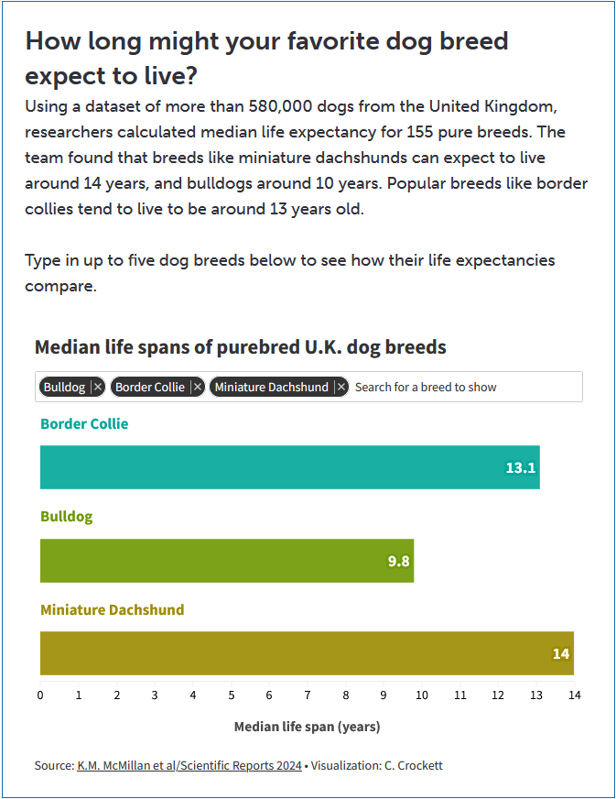
Source: K.M. McMillan et al/Scientific Reports 2024
Visualization: C. Crockett
Graph Questions
1. Between the border collie, bulldog, and miniature dachshund, which dog is expected to live the longest?

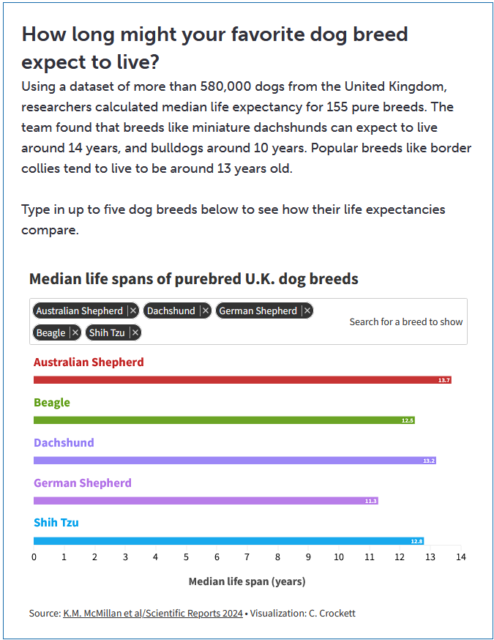
Source: K.M. McMillan et al/Scientific Reports 2024
Visualization: C. Crockett

2. How does the life expectancy of an Australian shepherd compare with that of a bulldog? Be as specific as possible.

3. Of the 8 dog breeds included in the two data visualizations above, put them in order of shortest life span to longest life span.

4. The data visualization is based on researchers’ analysis of over 580,000 records, including 284,000 from deceased dogs, in the United Kingdom. Do you think that the location has an impact on the life span? Please justify your answer.

