Student Worksheet: Hottest year on record
Directions: Since temperature recordkeeping began 150 years ago, the 12-month period from November 2022 through October 2023 was the hottest on record until temperatures in 2024 exceeded those in 2023. The heat raised sea surface temperatures, melted sea ice and endangered human health.
Read the short summary, graph title and caption before completing the questions below. Your teacher may have you use Padlet, Kahoot, or Mentimeter to provide responses.

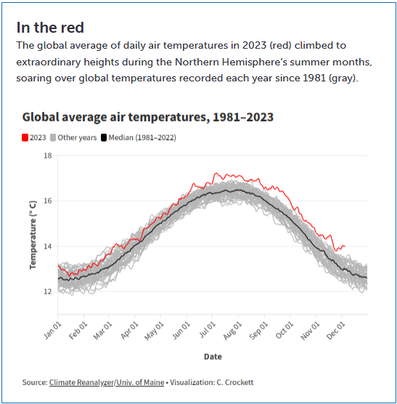
Source: Climate Reanalyzer/Univ. of Maine
Visualization: C. Crockett
Graph Questions
1. What was the approximate global average air temperature on March 1, 2023?

2. How does the median global average air temperature compare to the temperatures recorded in 2023?

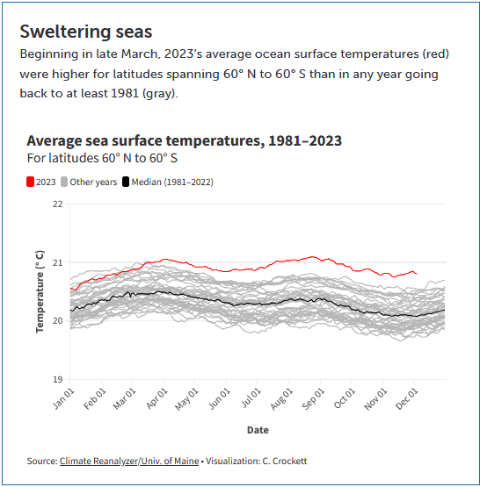
Source: Climate Reanalyzer/Univ. of Maine
Visualization: C. Crockett

3. What was the average sea surface temperature on August 1, 2023?

4. Which temperature fluctuates less, ocean surface temperature or air temperature? Provide evidence to support your answer.

