Student Worksheet: Antarctic sea ice
Directions: In 2023, the expanse of floating ice encircling Antarctica hit record lows throughout the year. Scientists expect dramatic declines in sea ice at Earth’s other pole but hadn’t observed major changes in the Antarctic until the last few years.
Read the short summary, graph title and caption before completing the questions below. Your teacher may have you use Padlet, Kahoot or Mentimeter to provide responses.
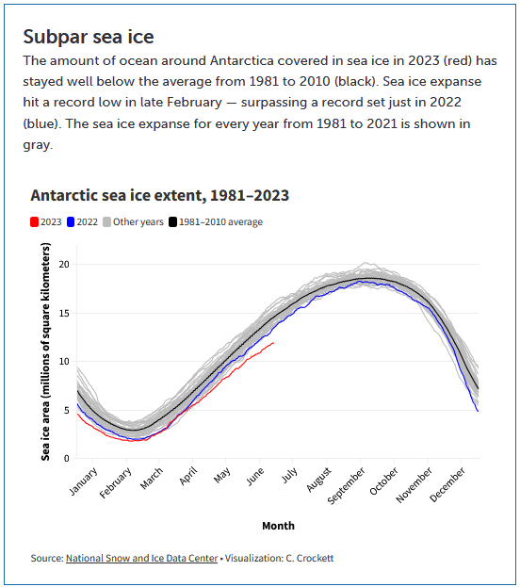
Source: National Snow and Ice Data Center
Visualization: C. Crockett
Graph Questions
1. Was there a time when the 2023 sea ice area was greater than (or at least equal to) that in 2022? If so, when?

2. Look at the month of June and compare the sea ice area from the three different time periods (1981–2010, 2022 and 2023). What does this tell you about the rate of change over time?

3. Thinking about human activity, what are some possible causes to the melting of the sea ice? Please explain how they are specifically linked to the melting of the ice.

4. Why do you think we should be concerned about the amount of sea ice shrinking? Give two specific examples

