Student Worksheet: Air pollution and human health
Directions: In August of 2018, scientists published research showing how air pollution shaves off about a year on average from human life expectancy. In more polluted regions of Asia and Africa, lives are shortened by 1.5–2 years on average. Loss in life expectancy rises with increasing concentrations of fine particulate air pollution (PM_{2.5}).
Read the short summary, graph title and caption before completing the questions below. Your teacher may have you use Padlet, Kahoot, or Mentimeter to provide responses.
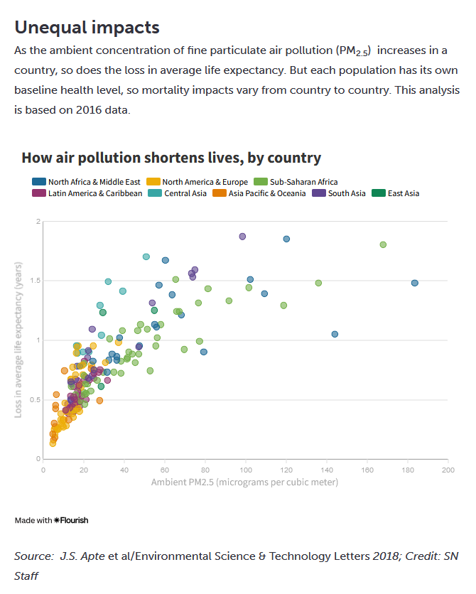
Graph Questions
1. What does PM_{2.5} mean?

2. What is the highest average loss in life expectancy according to the data visualization?
A. 2 years
B. 1.8 years
C. 1.0 year
D. 0.5 years
3. Which 3 areas are experiencing the highest loss in average life expectancy? Which 3 areas are experiencing the highest ambient concentration of fine particulate air pollution?

4. State the correlation between loss in average life expectancy and air pollution and give a possible explanation for it.

