Student Worksheet: Graph of the Week
Directions: Cases of sleeping sickness, a disease that can cause brain damage and death, are at an all-time low. An experimental drug called acoziborole could help to eliminate the nightmarish parasitic illness. Use the graph “Sleeping sickness efforts pay off” to analyze the reported cases of both forms of sleeping sickness from 1990 to 2021. Read the graph title and caption before completing the questions below.
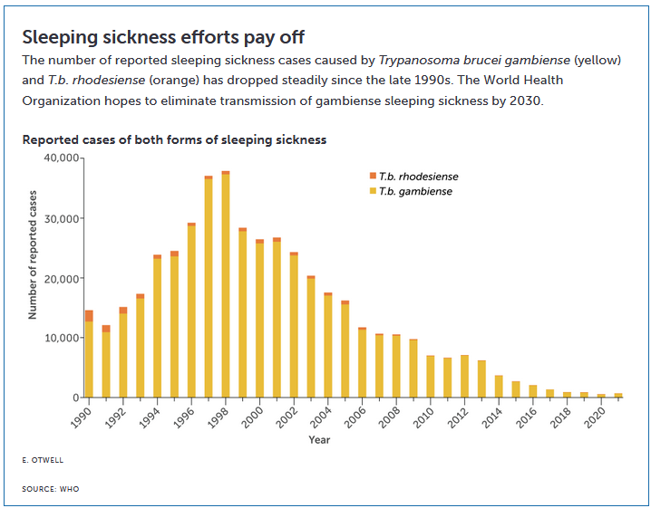

Graph Questions
1. Which year had the highest total amounts of both types of sleeping sickness cases?

2. Which year had the highest amount of T.b. rhodesiense-caused sleeping sickness?

3. Calculate the difference between the number of cases of T.b. gambiense at their highest point and their lowest point.

