Student Worksheet: Disease Eradication Data
Directions: The success of vaccines has sometimes obscured the power of infectious diseases to sicken, kill and upend lives. Still, the epidemics of the last century contain stories to listen to and learn from. Use the data table “Big Impact” to analyze how vaccines have impacted the number of disease cases. Read the data title and caption before completing the questions below.
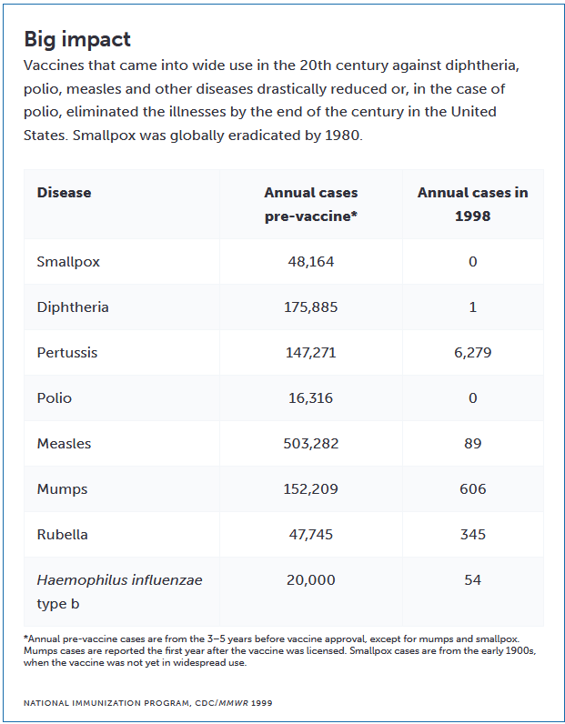
Graph Questions
1. According to the data table, which of the following diseases were drastically reduced or eliminated by vaccines in the 20th century in the United States? Choose all that apply.
a. Polio
b. Tuberculosis
c. Diphtheria
d. Malaria
2. In what year was smallpox globally eradicated?
a. 1970
b. 1980
c. 1990
d. 2000
3. Which of the following best describes the impact of vaccines on diseases in the 20th century?
a. Vaccines had no significant impact on disease prevention.
b. Vaccines only affected a few minor illnesses.
c. Vaccines drastically reduced or eliminated diseases like diphtheria, polio, measles, and smallpox.
d. Vaccines were only effective against bacterial infections.
4. Compare and contrast the impact of vaccines on diphtheria, polio, measles, and smallpox cases.

