**Student Worksheet: Amazon deforestation**

**Directions**: Scientists agree that the Amazon is in grave trouble because of human activities, such as deforestation, and climate change. Past studies have suggested certain rates of deforestation would trigger the Amazon to transform into a savanna, but many scientists now say the forest probably doesn’t have a single, clear tipping point. Still, researchers are working to understand what needs to be done — and how soon — to save the forest. Use the map and graph titled “Rate of deforestation in the Brazilian Amazon” to analyze the area and rate of deforestation in the Amazon. Read the map and graph title and caption before completing the questions below.

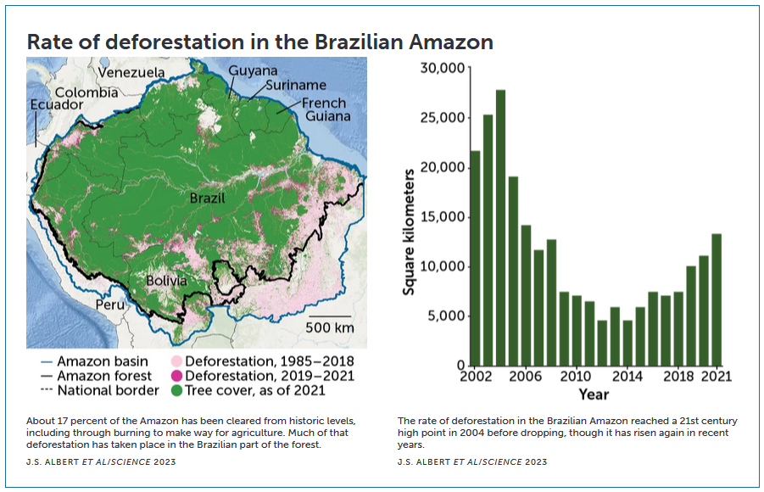

**Graph Questions**1. Of the two timeframes given on the map, which had more deforestation?

2. In what two years is deforestation the lowest according to the bar graph?

a. 2010 and 2014

b. 2012 and 2014

c. 2013 and 2015

d. 2014 and 2015

3. How many more square kilometers were destroyed in 2003 as compared to 2019?

a. 5,000

b. 10,000

c. 15,000

d. 20,000